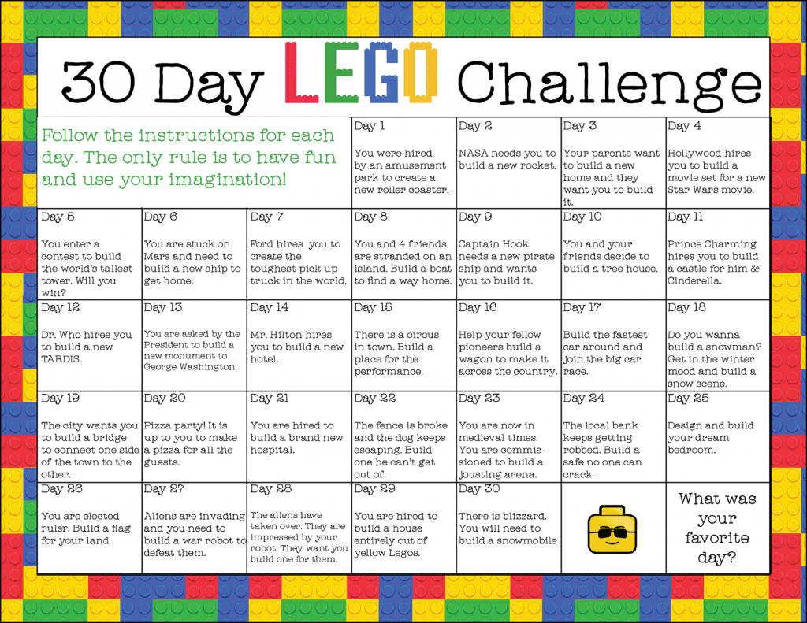
Whole School Project – Week 4

Pick 3 activities from the grid above and try them this week.
- They don’t necessarily need to be made out of LEGO – any building blocks will do
- You can choose to do only 1 BUT it better be a good one
- Send pics of the completed tasks to the normal email address.

